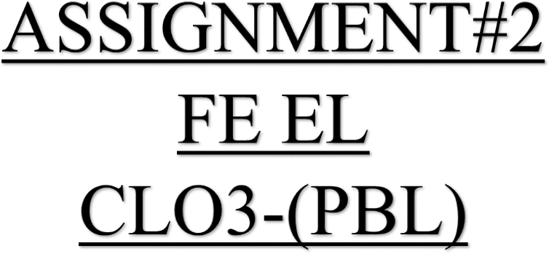

COVERING PAGE
Subject: PH-112 Max.Marks: 05 Type: Individual
Title: The purpose of this PBL is to study quantum mechanics and photoelectric effect by determining plank’s constant, work function and photon’s speed in the given problem

Linkage to Course Learning Outcome
CLO  Number |  | Description of CLO |  | DOMAIN | Taxonomy level | PLO
CLO-3 |  | Apply the concepts of Modern Physics to solve the problems. |  | Cognitive | 3 | PLO-2  (Problem Analysis)
Sr.no. | Problems Description
1. | To determine the work function and Planck’s Constant from the increasing relation between  wavelength and Stopping Potential.
2. | To determine the cut off wavelength for metal surface when illuminated by monochromatic light.
Sr.no. | Constraints/Assumptions
1. | Work function of Sodium and Silver is given that is 2.64ev and 4.73ev
2. | Same monochromatic light strikes on both metal surfaces
3. | Measure the K.E of electron from both the surfaces
4. | From Work function we can calculate the cut off wavelength for both metal
Sr.no. | Identification of Areas where use of computational/modern Tools usage is required.
1. | Firstly require a monochromatic light source
2. | For finding K.E and 𝛟𝑜 of electron, we use photoelectric apparatus and analytical software
3. | Visualization of data collected as graph in Microsoft Excel Software
4. | Report Writing in Microsoft word software
Sr.no. | Expected Outcomes
1. | Determination of (K.E) of electron from different metals and also its work function
2. | Understanding by using calculations and its formula
3. | Report writing with proper formatting
Sr.no. | Complex Engineering Activities  Preamble: Complex activities means (engineering) activities or projects that some or all of the following characteristics listed below:
 | Attributes of CEA |  | Description |  |  |  | Apply
1. | Range of resources |  | Involve the use of diverse resources (for this purpose resources  include money, equipment, materials, information and technologies). |  |  |  | Yes
2. | Level of Interaction |  | Requires solution of significant problems arising from interaction between wide ranging of conflicting technical, engineering and other  issues |  |  |  | No
3. | Innovation |  | Involve creative use of engineering principles and research based  knowledge in novel ways |  |  |  | No
4. | Consequences to  society and environ |  | Have significant consequences in range of context, characterized by  difficulty of prediction and mitigation |  |  |  | No
5. | Familiarity |  | Can extend beyond previous experience by applying principle base  approach |  |  |  | Yes
Teacher Signature…………………… Teacher Name………………………..

ASSIGNMENT#2 (CLO-3) DEPARTMENT OF ELECTRONIC ENGINEERING
MAX.MARKS:05
QUESTION NO 1: The data in table was obtained by Robert A. Millikan (United States, 1868-1953), who was awarded the 1921 Nobel prize in physics for his verification of the photoelectric effect. Millikan’s photoelectric data for lithium are:
Wavelength  (nm) | 433.9 | 404.7 | 365.0 | 312.5 | 253.5
Stopping potential (V) | 0.55 | 0.73 | 1.09 | 1.67 | 2.57

- Make a plot of the table on graph paper with proper scaling
- Find the Planks constant
- Work function for lithium
QUESTION NO 2: Sodium and silver have work function of 2.64eV and 4.73eV, respectively.
- If the surfaces of both metals are illuminated with same monochromatic light which metal will give off photons with greater speed? How much faster will those electrons be?
- Calculate the cutoff wavelength of both metals?

INSTRUCTIONS:
- Submit the assignment in A4 sheet, with name and roll no. written on the very right side of the sheet
- Last date for the submission is 18-NOV -2024

NED University of Engineer ing & Technology
Department of Electronic Engineering
Course Code & Title: PH-112 Assessment Rubric for PBL
Student’s Name: ………........... Roll No: ………..

Criterion | Level Of Attainment
 | Below Average (1) | Average (2) | Good (3) | Very Good (4) | Excellent (5)
Understanding the Problem | Didn’t understand the problem | Preparation of data | Correct data collection points | Correct measurement orientation | Correct data collection
Analysis of data | No data table in MS Excel | Correct data table in MS Excel | Graphs in MS  Excel | Discovering of relationship | Preparation of report
Timely Submission | No | ---- | ---- | ---- | Yes
Quality of Report | Covers no detail | Covers  limited details | Covers  required details | Covers full details | Presented in  professional style

Total Score = Instructor’s Signature:

